Secondary Roads Department APPLICATION FOR
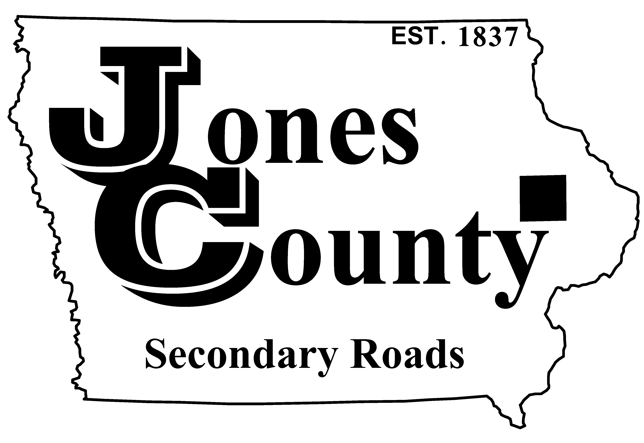
19501 HWY 64, P.O. Box 368 ANNUAL OVERSIZE/OVERWEIGHT PERMIT
Anamosa, IA 52205
Telephone: (319) 462-3785 Application No.: T-
Email: engineer@co.jones.ia.us Application Fee: $400.00

APPLICANT INFORMATION (PLEASE PRINT CLEARLY OR TYPE)

Vehicle Owner or Lessee: Requested Start Date:

Mailing Address:
(Street Address) (City) (State) (Zip)

Phone Number: Email Address:

POWER UNIT INFORMATION
Plate | State | Vehicle Identification Number (VIN) | Registered Weight | Year | Make

DIMENSIONS/WEIGHT
Total | Length | Width | Height | Total Weight | Front Projection | Rear Projection
 | (max = 120’-0”) | (max = 13’-6”) | (max = 15’-5”) | (max = 156,000 lbs) | (max = 15’-0”) | (max = 15’-0”)

MAXIMUM AXLE WEIGHTS ALLOWED ON THIS PERMIT = 20,000 LBS PER AXLE

AXLE WEIGHTS/SPACINGS (REQUIRED FOR SME VEHICLES ONLY)
Axle Number | 1 (front) |  | 2 |  | 3 |  | 4 |  | 5 |  | 6 |  | 7 |  | 8
Gross Axle
Weight (lbs)
Axle Spacing

Applicant Signature: Approved By:
(Customer or Authorized Agent) Date Jones County Engineer’s Office Date

Maximum dimensions and weight allowed on an annual oversize/overweight permit are:
- Length - 120’-0”
- Width - 13’-5”
- Height - 15’-5”
- Weight - 156,000 lbs

This permit is valid only for travel on state and U.S. highways in Iowa. It is not valid for travel on interstate highways, state and U.S. highways, county roads not within Jones County, or city streets. Separate permits must be obtained from the proper governing authority for travel on these roadways.

It is the responsibility of the carrier to route themselves around low clearances, construction projects, embargoed roads and bridges.

Permits can be issued only for transporting single articles that exceed statutory size limits unless the inclusion of additional articles does not cause the size or weight to further exceed the statutory limits.

