Secondary Roads Department APPLICATION FOR
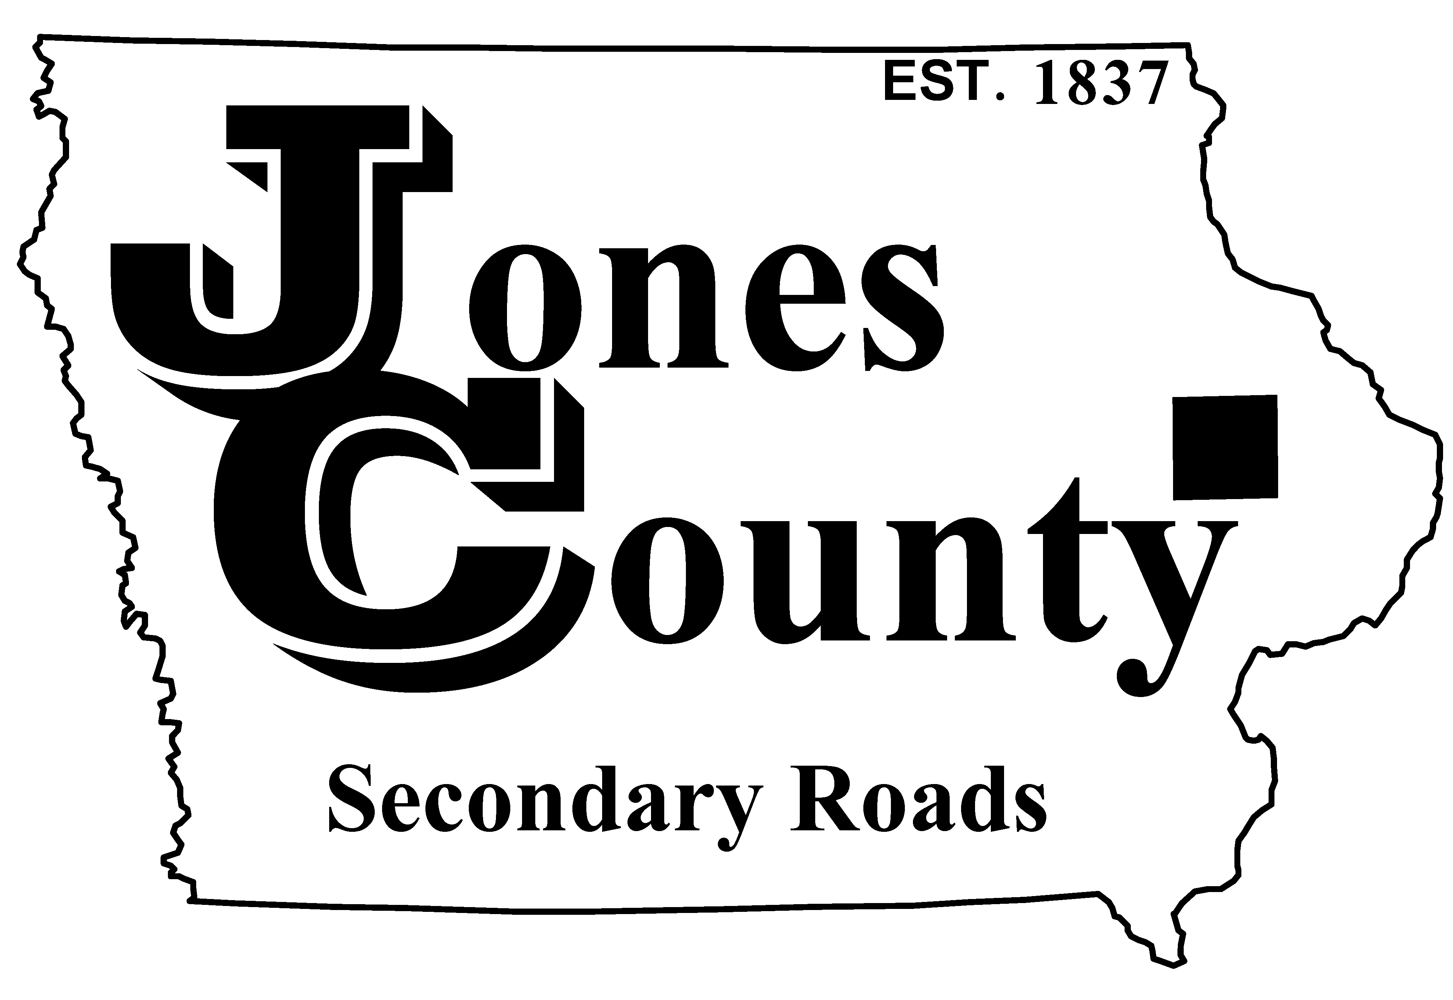
19501 HWY 64, P.O. Box 368 NO SPRAY LOCATION
Anamosa, IA 52205
Telephone: (319) 462-3785 Application No.: S-
Email: engineer@co.jones.ia.us Application Fee: $75.00

APPLICANT INFORMATION (PLEASE PRINT CLEARLY OR TYPE)

Applicant Name: Owner Name (if different):

Mailing Address:
(Street Address) (City) (State) (Zip)

Phone Number: Cell Phone No.:

NO SPRAY LOCATION

Address/Road Name: Township: Sec.:

Location Description:
(Example: “Centered on house” or “From 200’ N of driveway to 100’ S of driveway”)

Side of road (North, South, East, or West): Length of location: FT.

Applicant Responsibilities:
- Maintenance and installation of ‘No Spray’ signage. (Application Fee includes two (2) “No Spray’ Signs.)
- Signs are to be mounted at least four (4) feet above the ground line and placed within three (3) feet of the right-of-way line.
- Control of noxious weeds (as listed in Chapter 317 of the Iowa Code), trees and brush within designated No Spray Location.

In signing and accepting this No Spray Application I agree to control the growth of noxious weeds, trees and brush within No Spray Location as listed above and according to the Jones County No Spray Application Policy. If Applicant does not control noxious weeds, trees and brush within designated No Spray Location the County may cut, spray, or otherwise control the noxious weeds, trees and brush according to County practice and this Application shall be null and void.

Applicant Signature: Date:

FOR COUNTY USE ONLY

Special Provisions:

Additional Signs: @ $25.00 per sign Additional Fees: $

Authorized By: Date:

